Assignment Number 2

Question 1

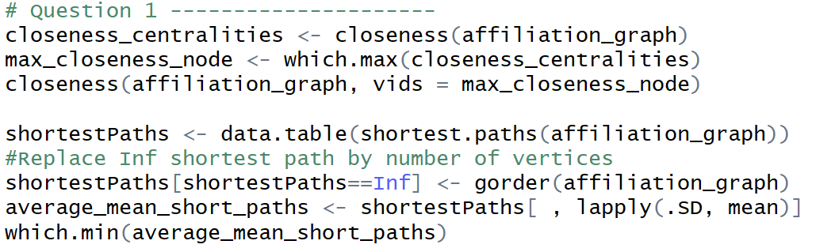

1. Which ﬁrm is the center of the venture capital ﬁrm network as of July 2014? 
2. Firm with lowest average shortest path

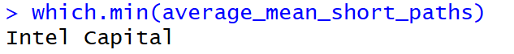

1. Mean shortest distance of all vertices

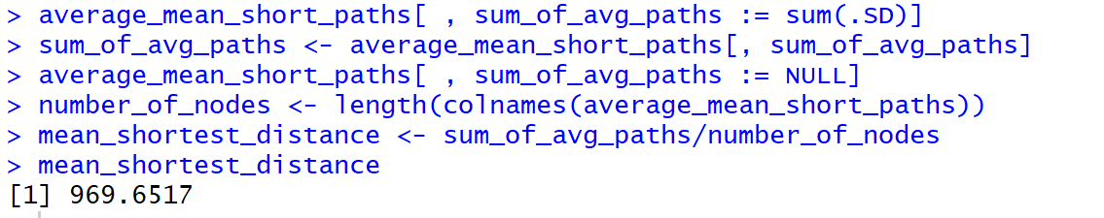

The average above is high because a large number of nodes have ‘Inf’ as shortest distances between nodes, as shown below.

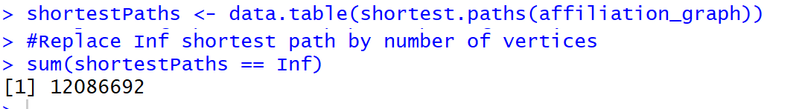

Question 2

1. Cumulative over months.

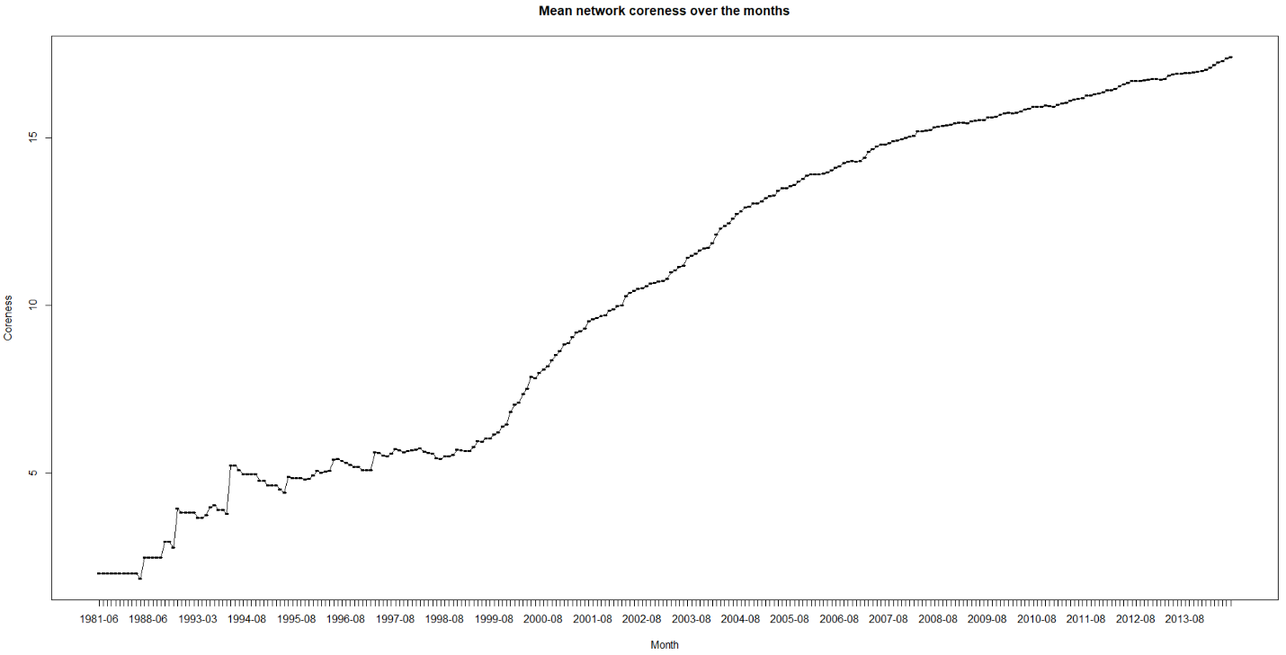

1. Decay considered

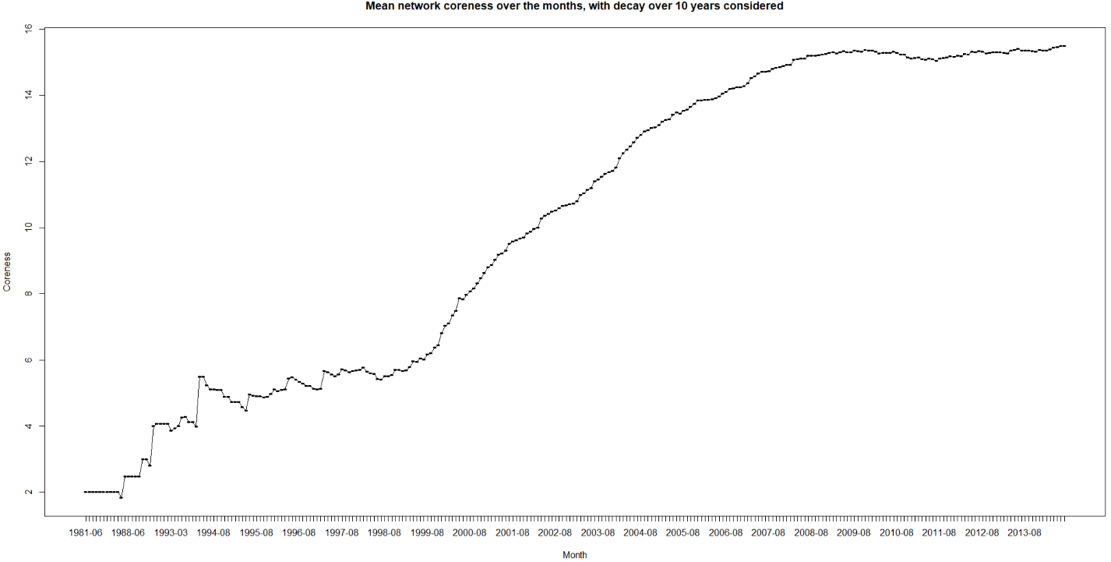

Question 3

Below we can the number of clusters and number of vertices in each cluster. As we can notice there is huge core clustered group with 10647 vertices(companies) in it.



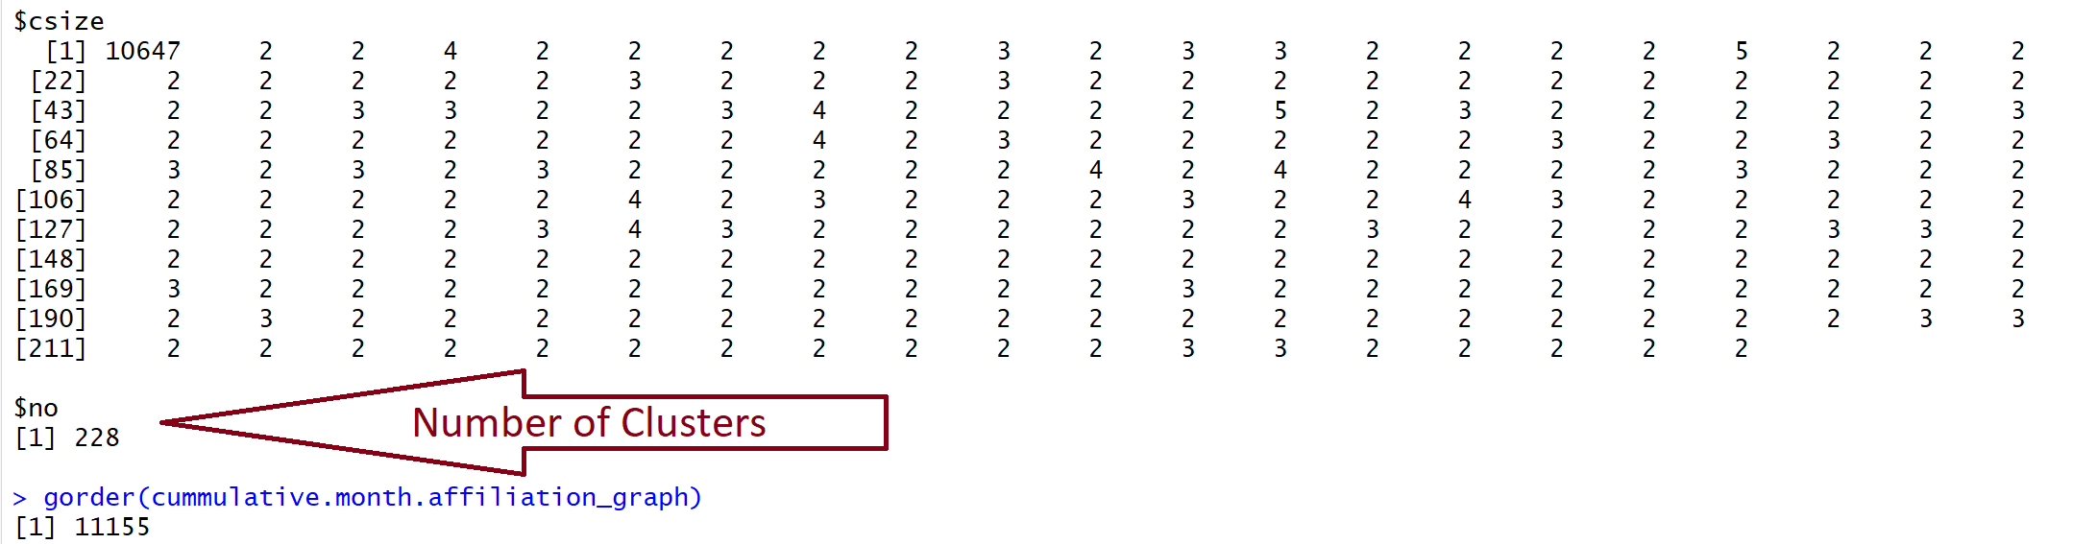

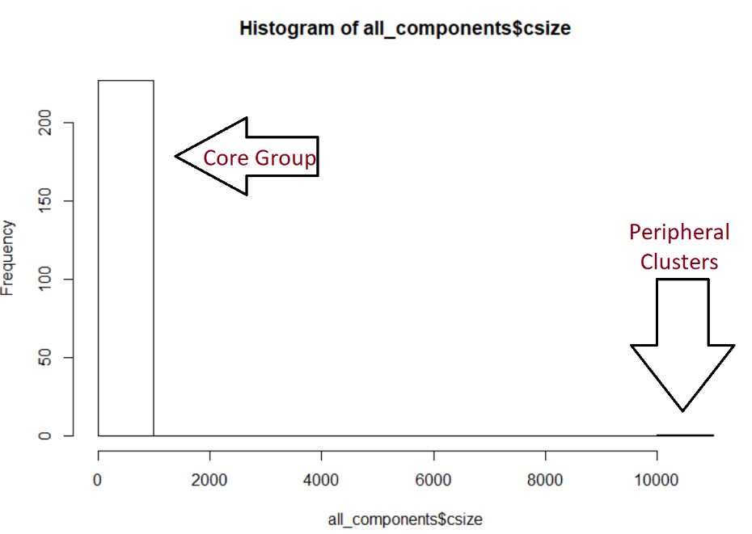

Graph in NodeXL

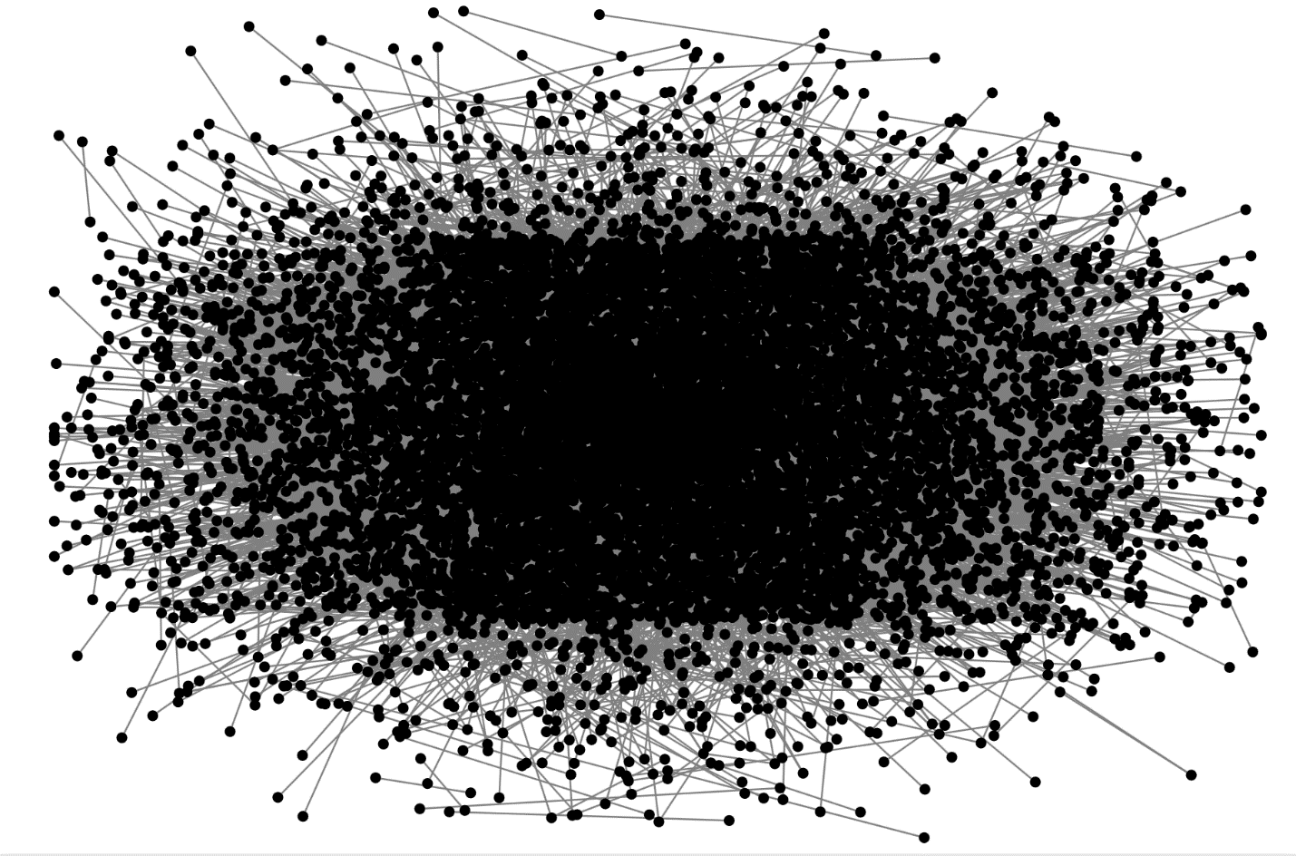

Question 4

1. As the below graph shows the ore central the company is in the network the more number of investments it does. I have taken log of closeness to make the results and pattern shown clearly.

Closeness vs number of investments.

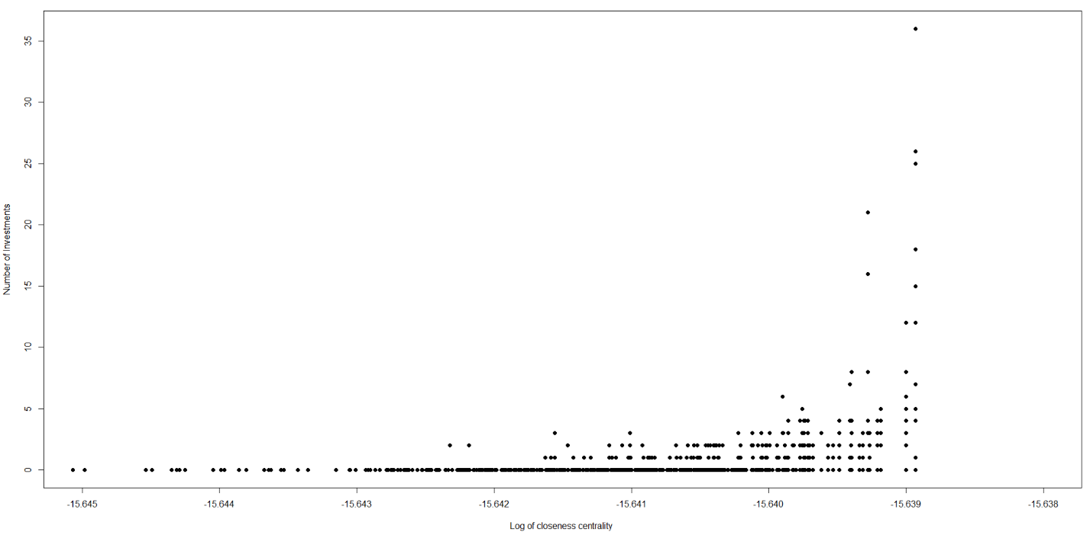

Degree vs Number of investments.

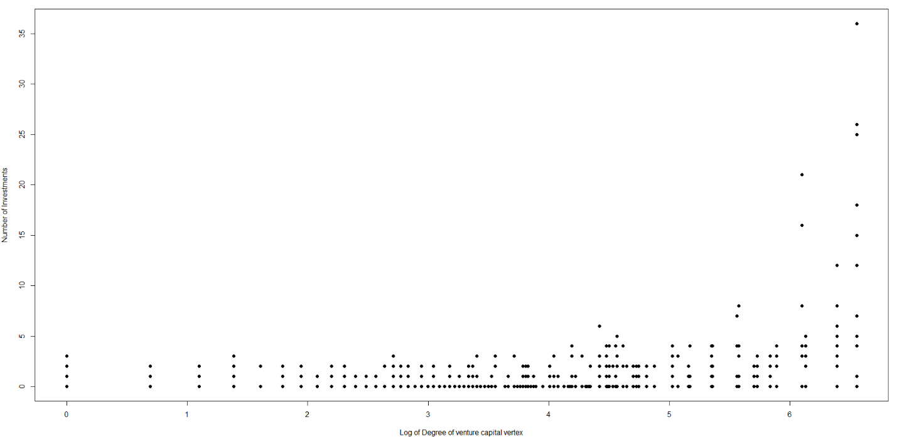

Betweenness vs Number of investments made.

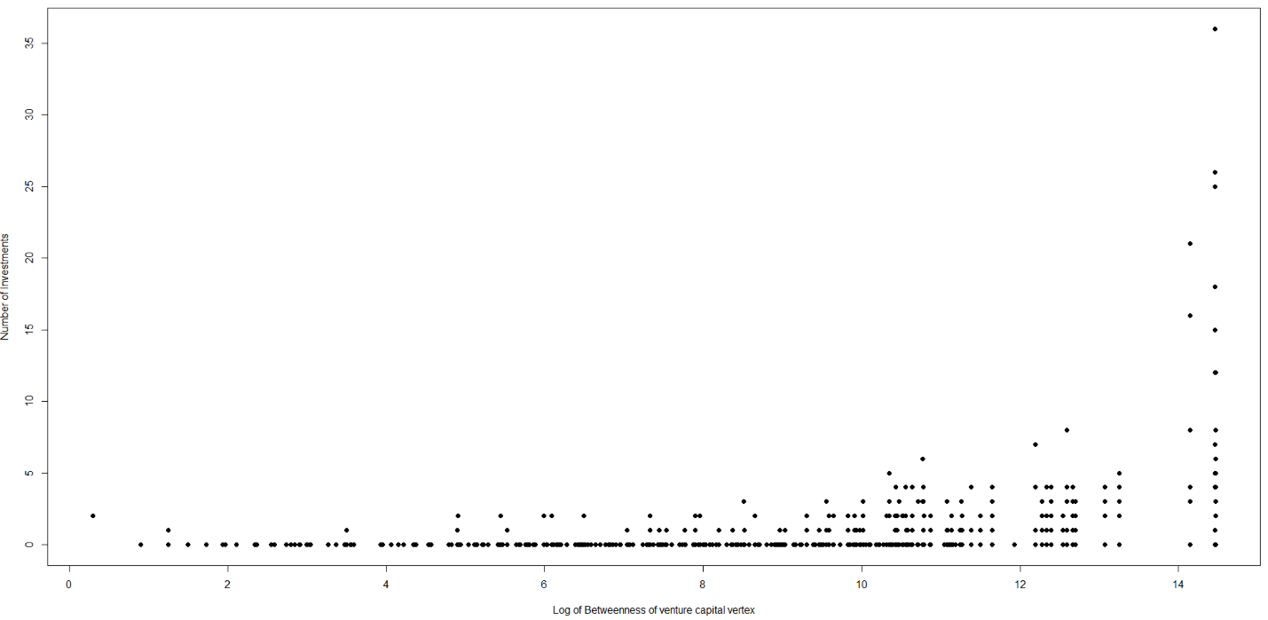

1. Success of the firm vs centrality measure.

Below is the kernel density graphs for the centrality measures vs the success of firm(Not out of business)

Closeness vs success of the firm

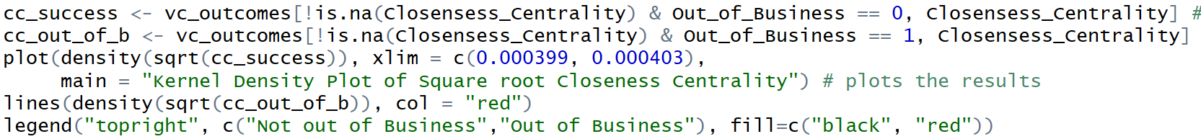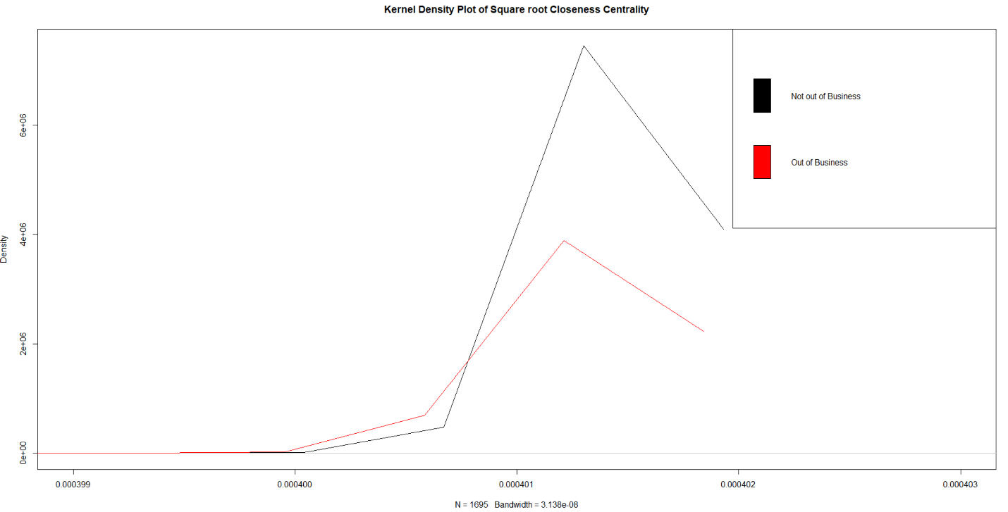

Degree vs success of the firm.

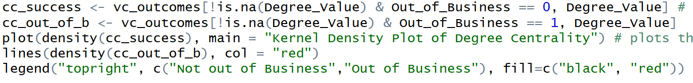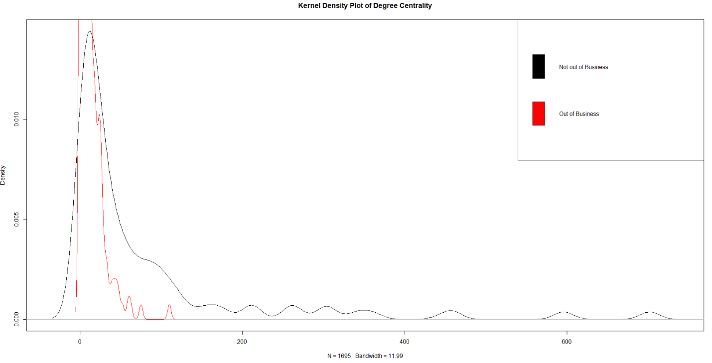

Betweenness vs Success of the firm.

